Transrectal Color and Pulse Doppler Ultrasonography of Polyps and Carcinomas of the Rectum.
*Zsuzsa Jakab, **Tibor Duliskovich, ***György Székely, *Béla Lestár, *László Ritter
*Haynal Imre Medical University, **National Institute of Radiology and Radiation Physics,
***Szent János Hospital, Budapest, Hungary

Purpose:
To study the vascularity of polyps and carcinomas of the rectum. To investigate the ability of color Doppler study on tumor vessels to discriminate benign masses from malignant tumors.

Materials and Methods:
Acuson 128 XP/10, 7 MHz transrectal transducer.
After a survey scan of tumor morphology, color Doppler sonography was performed to detect vessels within the masses. All tumors were subjectively judged for the amount of color signal indicating the presence of vascularity. Pulsatility indices for arterial waveforms were calculated in all cases. In the tumor group we have calculated the mean PI-s of every single patient. Analysing the data we have considered all the measured PI-s in the polyp group, because of the small number of patients.
Flow characteristics and PI-s within the malignant tumor tissue and within the polyps were compared.

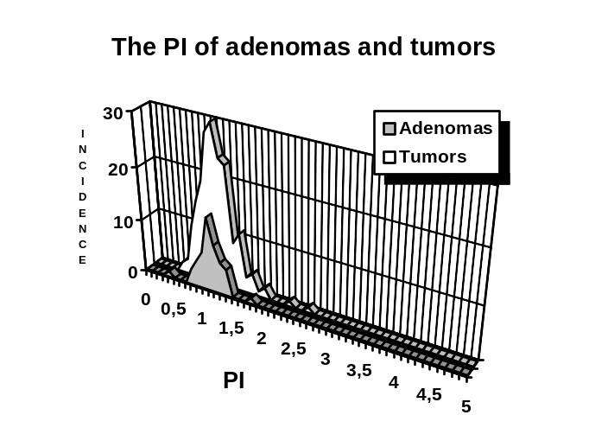Results:
Comparison of flow characteristics of our 22 benign and 186 malignant lesions revealed no difference between the two groups. Each of the rectal masses showed hypervascularity, a low resistance type flow with low pulsatility indices.

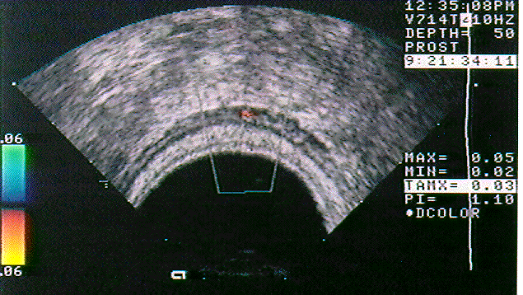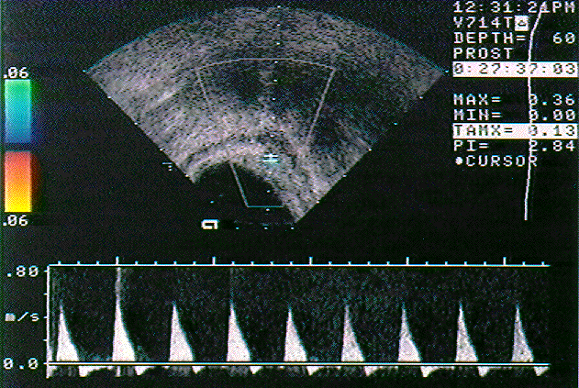
Doppler signals from the normal rectal wall. High resistance type of flow. PI: 2.84.

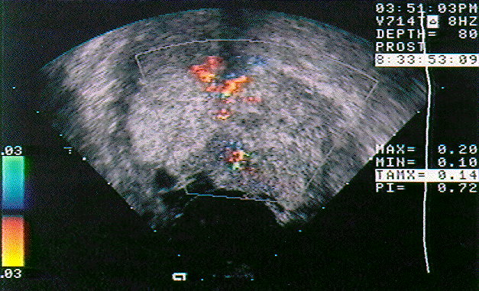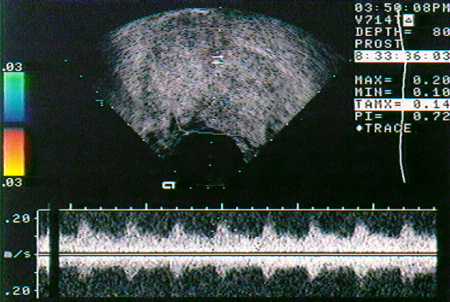
Color and pulse Doppler signals from a tubulous adenoma. Hypervascularisation. Low resistance type of flow with low PI: 0.72.
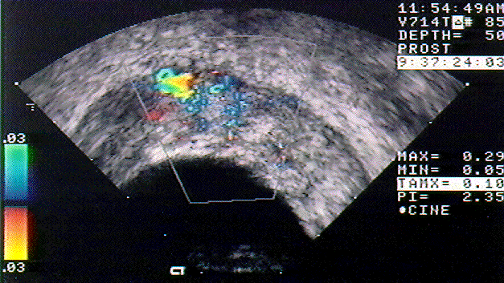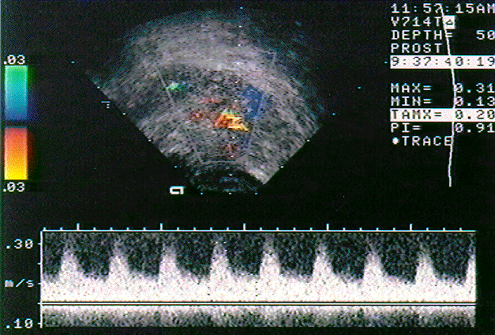
Large infiltrating rectal cancer. Hypervascularisation. Low resistance type of flow, increased diastolic flow. PI: 0.91.

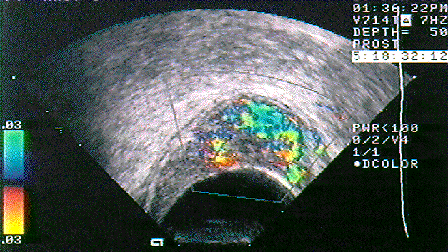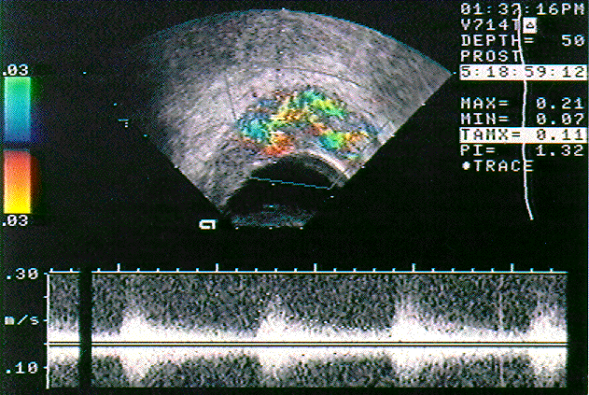
T1 rectal cancer. Hypervascularisation. PI: 1.32.

Conclusion:
In general, endosonography is the most accurate method used to discriminate between T1 carcinomas and advance-stage tumors, however our experience with transrectal color Doppler ultrasonography suggests that it is unable to differentiate between polyps and T1 carcinomas.

 | Mean PI | Minimum | Maximum | Medián | SE | P
Tumor | 1.077  ±0.298 (SD) | 0.49 | 2.59 | 1.05 | 0.019 | >0.98
Adenoma | 1.071  ±0.207 (SD) | 0.38 | 1.72 | 1.07 | 0.029
PI: Pulsatility index SD: Standard deviation SE: Standard error P: Significance

Contact persons:

Tibor, Dulikovich MD | Zsuzsa, Jakab MD
National Institute of Radiology | II Belklinika
and Radiation Physics | Radiolgical Department
Szabolcs u. 33-35 | Szentkirályi u. 46
Budapest | Budapest
Hungary | Hungary
1135 | 1088

